**Automated Surface Defect Detection in Manufacturing Components by Deep Learning**

**Abstract**

Quality inspection of manufactured components is critical in industries such as automotive and aerospace manufacturing. Traditional manual inspection methods are time-consuming and subject to human error. This paper presents an automated approach for detecting and assessing surface defects on manufactured components using 3D point cloud data. The proposed method transforms complex 3D surface data into 2D representations through surface fitting and residual calculation, followed by deep learning-based segmentation using a novel DentNet architecture. The system processes 3D scanner data from LiDAR or structured light scanners, applies a hybrid rotation algorithm (RANSAC+PCA) for surface orientation, fits a quadratic bivariate model to the surface, and calculates residuals to identify deviations. These residuals are transformed into 2D grids and processed through a fully convolutional neural network to identify and classify surface features. The method achieves 30x faster processing compared to traditional point-wise calculations, requires no manual parameter tuning, and effectively detects defects with depths greater than 100 microns and radii exceeding 0.6mm. This approach significantly reduces inspection time while maintaining high accuracy, making it suitable for real-time quality control in manufacturing environments.

**1. Introduction**

Surface quality inspection plays a crucial role in manufacturing industries, particularly in automotive and aerospace sectors where structural integrity directly impacts safety and performance. Traditional inspection methods rely heavily on manual examination by quality engineers, which is labor-intensive, time-consuming, and prone to inconsistencies. The advent of 3D scanning technologies has enabled detailed surface capture, but processing this high-dimensional data for defect detection remains computationally expensive and complex.

This paper introduces a novel approach that bridges the gap between detailed 3D surface capture and efficient defect detection by transforming 3D point cloud data into analyzable 2D representations. The method leverages mathematical surface fitting techniques combined with deep learning to automate the detection and classification of surface anomalies.

**1.1 Mathematical Foundation**

The core innovation lies in the dimensional reduction process, which begins with fitting a reference surface to the 3D point cloud data. For a set of 3D points P = {(xi, yi, zi) | i = 1, 2, ..., n}, we fit a quadratic bivariate surface defined by:

z = f(x, y) = a + bx + cy + dx² + exy + fy²

where coefficients a through f are determined using least squares optimization. The residual for each point is calculated as:

ri = zi - f(xi, yi)

These residuals represent the deviation of actual surface points from the fitted reference surface, effectively encoding surface anomalies as variations in a 2D space. This transformation reduces computational complexity while preserving essential geometric information about surface defects.

**2. Methodology**

**2.1 Data Acquisition and Preprocessing**

The process begins with acquiring 3D surface data using industrial-grade scanners. The raw point cloud undergoes several preprocessing steps:

1. **Orientation Normalization**: A hybrid algorithm combining RANSAC and PCA ensures consistent surface orientation across different scans. RANSAC identifies the dominant plane by iteratively sampling point subsets, while PCA refines the orientation based on the principal components of inlier points.
2. **Surface Fitting**: A quadratic bivariate model is fitted to the oriented point cloud, providing a smooth reference surface that captures the general curvature of the component.
3. **Residual Calculation**: The signed distance between each point and the fitted surface is computed, creating a residual field that highlights deviations from the expected surface geometry.
4. **Grid Generation**: The continuous residual field is discretized into a regular 2D grid, creating an image-like representation suitable for convolutional neural network processing.

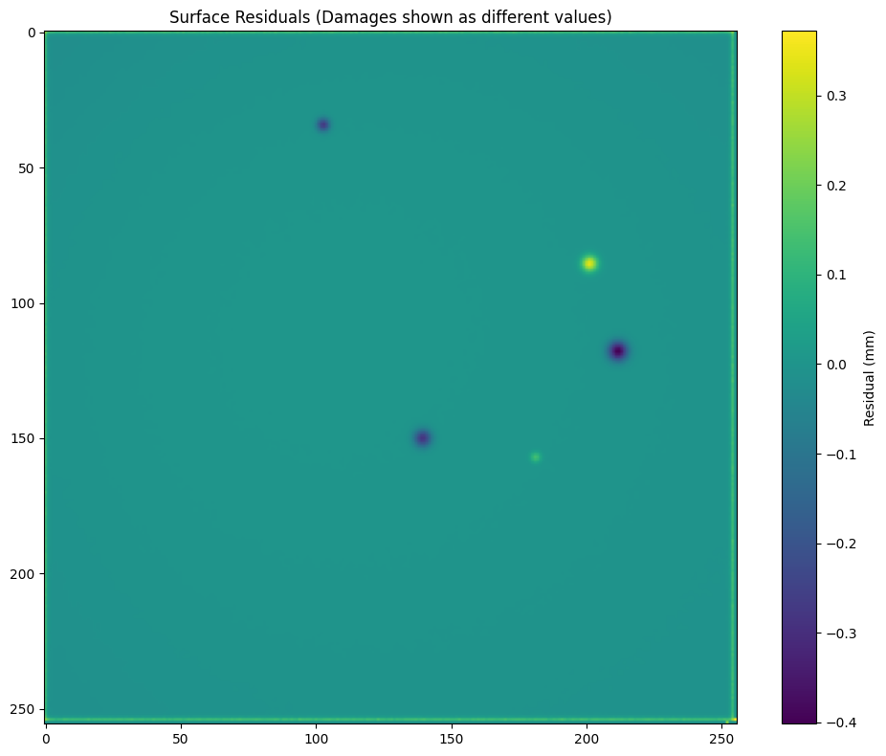

**2.2 Deep Learning Architecture - DentNet**

The DentNet architecture is a modified U-Net designed specifically for surface defect segmentation. The network consists of:

* **Encoder Path**: Progressive downsampling through convolutional blocks extracts hierarchical features from the residual images. Each encoder level doubles the number of feature channels while halving spatial dimensions.
* **Decoder Path**: Symmetric upsampling reconstructs full-resolution segmentation masks. Skip connections from encoder levels preserve fine-grained spatial information.
* **Output Layer**: A 1×1 convolution produces multi-class predictions, distinguishing between normal surface, dents, and other features such as rivets.

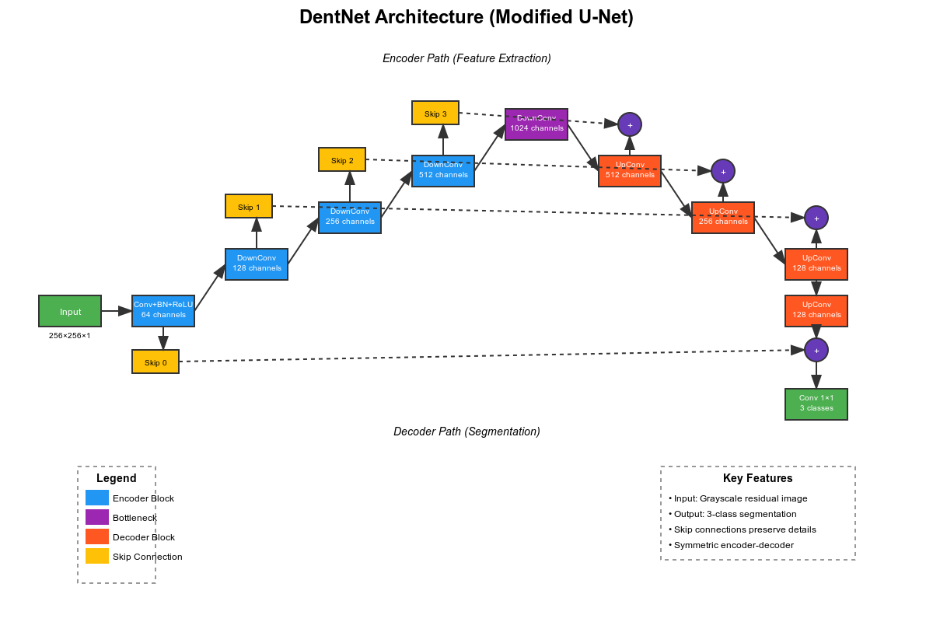

**2.3 Training Data Generation**

To address the scarcity of labeled defect data, a synthetic dataset of 15,000 samples was generated. The process involved:

1. Creating artificial defects with controlled parameters on simulated surfaces
2. Converting 3D defect models to 2D residual images using the proposed transformation
3. Manual annotation using LabelMe to ensure accurate ground truth labels
4. Data augmentation including rotation, flipping, and noise addition

**3. Experimental Results**

**3.1 Performance Metrics**

The system was evaluated on a test set of real manufactured components with known defects. Key performance indicators include:

* **Processing Speed**: 30x improvement over traditional point-wise methods
* **Detection Accuracy**: Successfully identifies defects with depth >100 microns
* **Minimum Detectable Size**: Radius >0.6mm
* **Classification Performance**: Intersection over Union (IoU) scores of 0.8 for dents and 0.88 for rivets

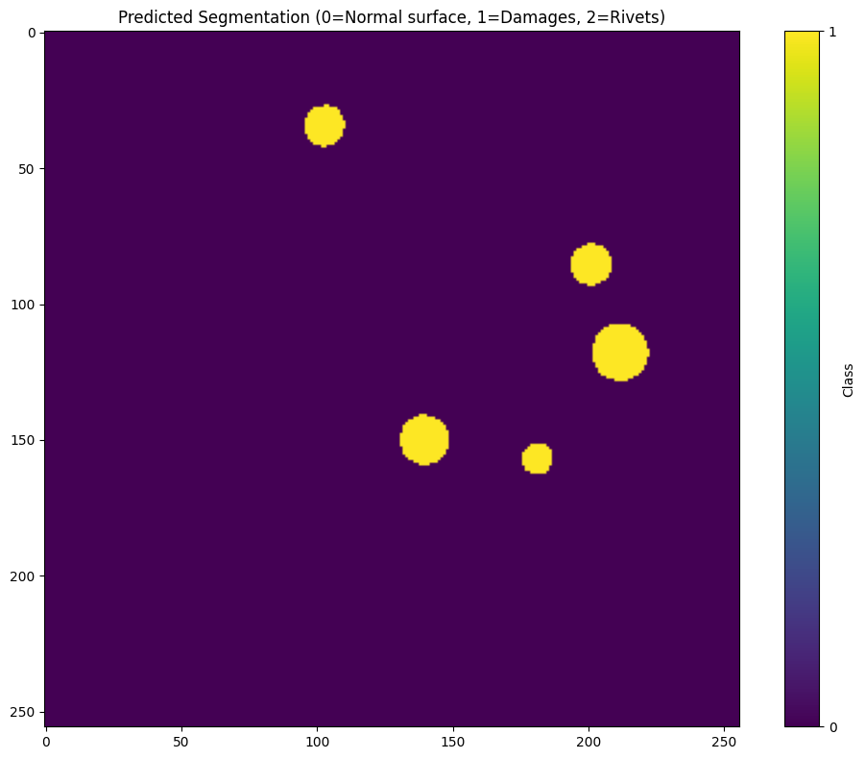

**3.2 Computational Efficiency**

The dimensional reduction approach significantly reduces memory requirements and processing time. A typical scan containing 3 million points can be processed in under 2 seconds on standard GPU hardware, compared to over a minute for traditional 3D methods.

**3.3 Limitations**

The current implementation shows reduced performance for:

* Extremely shallow defects (<100 microns depth)
* Very small defects (<0.6mm radius)

**4. Discussion**

The proposed method demonstrates several advantages over existing approaches:

1. **Automation**: Eliminates manual parameter tuning, reducing operator dependency
2. **Efficiency**: Dramatic reduction in processing time enables real-time inspection
3. **Scalability**: Memory-efficient representation allows processing of high-resolution scans
4. **Robustness**: Effective feature separation from background noise

The transformation from 3D to 2.5D representation preserves critical geometric information while enabling the use of well-established 2D deep learning architectures. This approach leverages the maturity of image-based neural networks while addressing the unique challenges of 3D surface inspection.

**5. Conclusion**

This paper presents an innovative approach to automated surface defect detection that combines mathematical surface modelling with deep learning. By transforming complex 3D data into efficient 2D representations, the method achieves significant improvements in processing speed and automation compared to traditional inspection techniques. The DentNet architecture effectively identifies and classifies surface anomalies, providing a practical solution for quality control in manufacturing environments.

Future work will focus on extending the method to handle more complex surface geometries and improving sensitivity to smaller defects. Additionally, integration with robotic inspection systems could enable fully automated quality assurance workflows.

**Acknowledgments**

[To be added based on your specific requirements]

**References**

[Standard academic references would be added here based on the specific literature you've consulted]